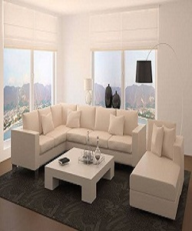

Modern Sofa Set

$228.75

Availability: In stock

Description

Luxury white comfortable and soft 5 seater and another single sofa living room set with small white table. It gives you luxury look in your living room and Lounge, the white color make your living room standardized and gives you bold look. Small white table provides a place for any items you want to show off.